TITLE OF YOUR EXTENDED ABSTRACT (Times New Roman, Bold 14pt centered)

Author, A¹, Author, B², and Author, C³ (TNR 12pt centered)

¹Institution 1(TNR 12pt centered)
²Institution 2 (TNR 12pt centered)
³Institution 3 (TNR 12pt centered)
E-mail (corresponding author)

Keywords: (maximum 8)

- INTRODUCTION (headlines: TNR Bold, 12pt)
Papers of relevant topics within the conference theme are invited for oral presentations. Authors are requested to submit an extended abstract not exceeding four (4) pages (approximately 900-1000 words) in English.
The extended abstract must include the title, author(s) introduction, methodology, results and discussion, conclusion and references. The manuscript should be prepared on an A4-sized paper with 25 mm margins on all sides and typed with single spacing using size 12 Times New Roman font. All illustrations must be prepared inside of the main text.

- METHODOLOGY (headlines: TNR, Bold, 12pt)

The methodology must be clearly stated and described in sufficient detail or with sufficient references.

- RESULTS AND DISCUSSION (headlines: TNR Bold, 12pt)
The findings and arguments of the work should be explicitly described and illustrated. Supporting figures, tables and images:
All the tables, images and figures should be centered. Figures and images should be numbered and figure headers should be placed under the figure or image; as for the tables, they should also be numbered and the table header should be placed at the top. References (if any) of the tables, figures and images should be presented right under the tables, figures and images in the form of author surname and publication date.

Examples:

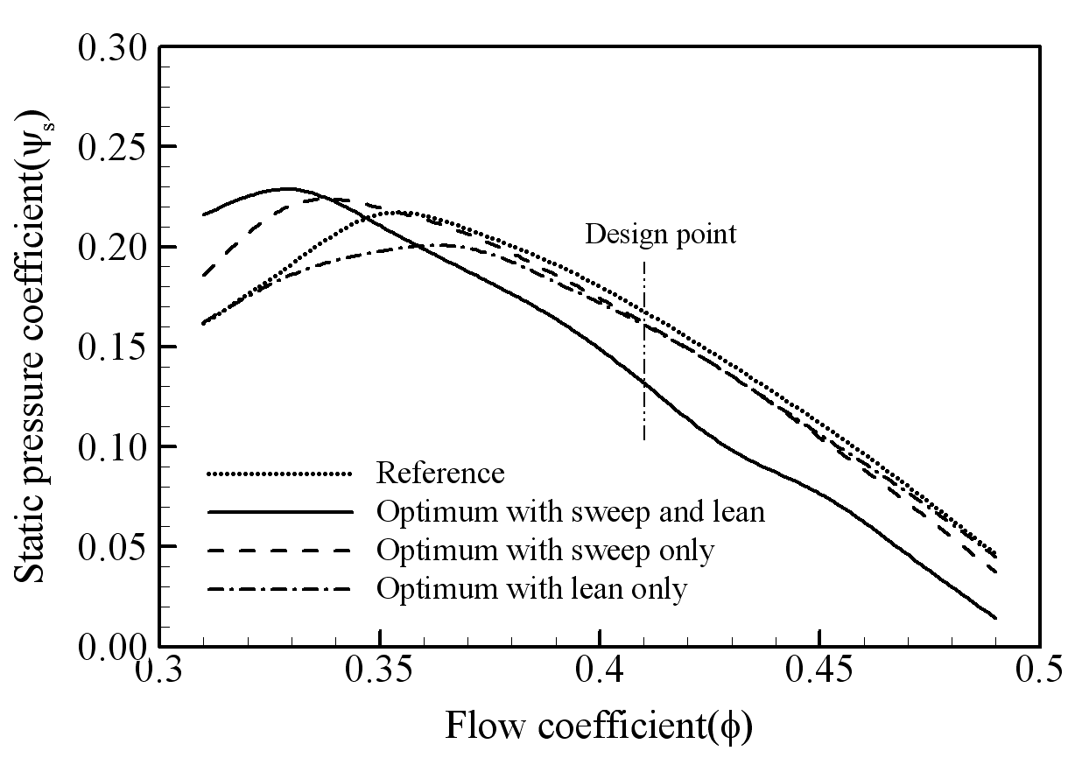
Figure 1. The caption heading for a figure should be placed below the figure and within figure/illustration width.

Table 1. Caption heading for a table should be placed at the top of the table and within table width.
(Use “time news roman” font, size 10pt, No spacing after table title)
 | A | B | C | D
A | Aa | Ab | Ac | Ad
B | Ba | Bb | Bc | Bd
C | Ca | Cb | Cc | Cd
D | Da | Db | Dc | Dd
E | Ea | Eb | Ec | Ed

Figures must be original, computer-generated or drafted, and placed within the text area where they are discussed.

- CONCLUSION (headlines: TNR Bold, 12pt)
Conclusions should include (1) the principles and generalisations inferred from the results,
(2) practical implications of the work, and (3) conclusions drawn and recommendations.

- REFERENCES (headlines: TNR Bold, 12pt)
References should be organized in alphabetical order and follow consistent referencing format, such as the Harvard style.

Example:
In-text: According to Pintz and Posey (2013) or (Pintz and Posey, 2013)
Reference list:
Pintz, C. and Posey, L. (2013). Preparing students for graduate study: an eLearning approach. Nurse Education Today, 33 (7), 734-738. Available from http://science direct.com/science/article/pii/S02606917 12003930 [Accessed 13 January 2015].

